Finding prime / composite no.
The no is having 2 factors or the no divisible with 1 and itself is called prime.
2 factors are 1 , 2
3 factors 1 , 3
4 factors 1,2,4 🡸 composite no
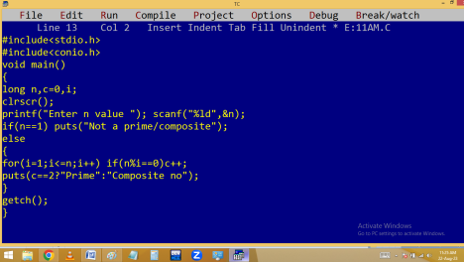

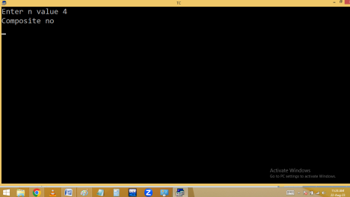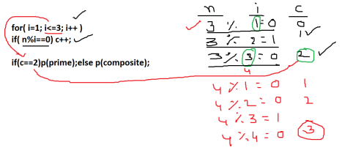Method 2:
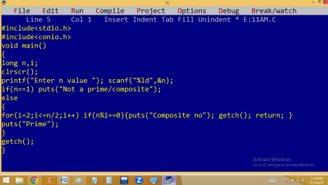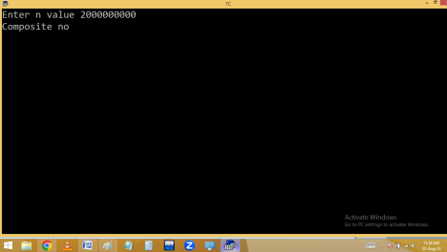
Twisted prime:
Given no and reverse no both are primes.
13 and 31 both primes
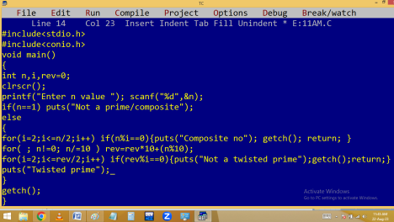

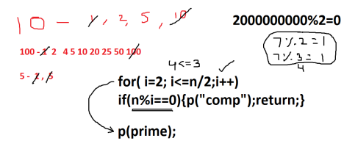Fibonacci series:
n=5 🡺 0 1 1 2 3
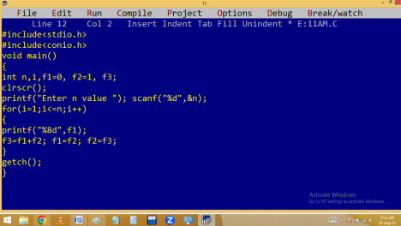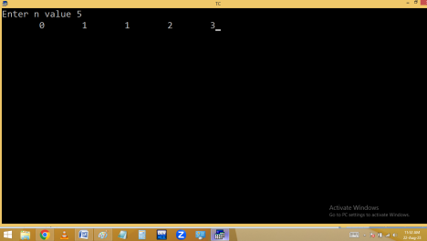
Finding Armstrong no
1 is a single digit no 🡺 1¹= 1
2 is a single digit no 🡺 2¹= 2
9 is a single digit no 🡺 9¹= 9
12 is a double digit no 🡺 1²+2²= 5
153 is a 3 digit no 🡺 1³+ 5³+ 3³= 1 + 125+27 = 153 370, 371, 407, 1634, 8208,…..
1634 is a 4 digit no 🡺 1⁴+6⁴+ 3⁴+ 4⁴= 1634
Printing below series.
n=5 🡺 1+2+3+4+5=15
Without using ‘\b’:
n=5 🡺 1-2+3-4+5=3
n=5 🡺 1²+ 2²+ 3²+ 4²+ 5²= 55
n=5 🡺 1 + 1/1 + 1/2 + 1/3+ 1/4 +1/5= sum

